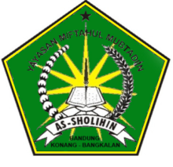

**STRUTUR PERLOMBAAN PAKU DALAM BOTOL**

**YASMIN**

**MASA JUANG 2017-2018**

Aisyah (9)

(4)

Funaimah(4)

Roihan (6)

Asis (5)

Jamil (7)

Solihin (8)

Fitriadi (7)

Azmil (4)

sofia (9)

Rosidi (5)

Ridoi(8)

Funaimah (6)

Roni (5)

Homsiyah (7)

Muzammil (6)

Aisyah (9)

Funaimah (6)

Buhori (8)